Text for the new web site

Dr. Tyurin will start his techical solution of the identified environmental Earth concern from the establishing the new manufcaturing site for the carbon negative manufacture of fuel isobutanol from air CO2.

The proposed 30 million gallons per year manufacturing site looks just like this picture.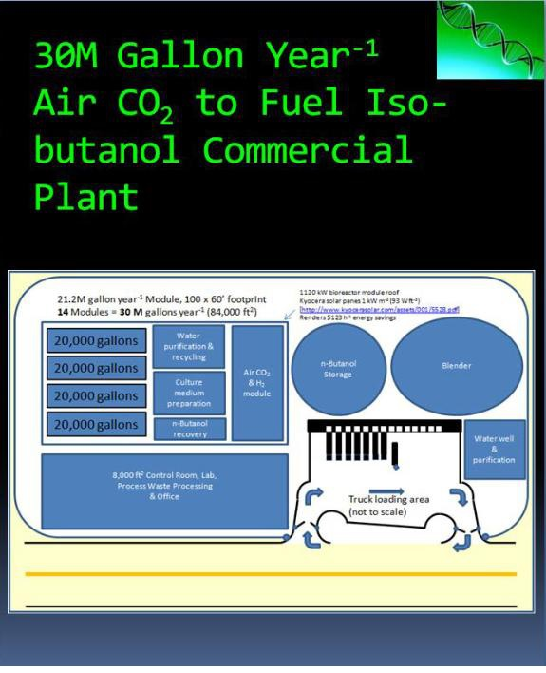

This plant will be totally clonable. Essential to note, that Dr. Tyurin plans to choose his plant location at the corporate site, located as close to the Mexican border as possible due to the close distance to the Earth Equator giving enough Sun light for said manufacturing site. The need for that is totally geographical, since at the tropical areas, areas, close to Equator (but still in the Continental United States). iHere, it is possible to collect enough Sun light to extract from the Sun light the solar energy using the modern highly efficient solar panels to make the new manufacture completely independent from the grid. Said solution is possible. The solar panels have to be combined with the batteries to ensure non interrupted manufacture at night time, and also, there has to be the connection to the systems of extra energy supplyinng, since it is now hard to predict the amount of totally sunnny days per year, etc. The batteries are planned to get from the shipyards, where out of date submarines are located. Modern out of date submarines have plenty of the alkaline batteries with the service dates 35-40 years beyond the year of such sub placement at the shipyard. There will be the need to explore said submarines for obtaining from them the DC motors with various power rating, up to several hundred kilowatts, to ensure the plant will be operating independent from the greed, with no need for the constant DC solar power conversion to the AC.

In additon to said 30 Million Gallons per year plant, we also plan to organize our laboratory facility and the facility for life or the personnel, working on said plant and in the labs, plus the service people to ensure the site security, safety, etc, since there will be the obvious active resistance of the existing petroleum/ gasoline/diesel fuel maufacturers to said manufacturing plant and the related laboratories. The security has to be the most sophisticated, ensuring even military force detention attemting (even theoretically) to interrupt our RnD and the manufacturing processes of said R n D and of the manufcaturing site. We will be living on said site, with the use of the corporate cars and helicopters for the transportation purposes. There are the existing ideas on the workforce compositon and its attraction, etc. The emergency transportation will be using the helicopters to San Antonion and to Houston. The proposed site location is the neihborhood of Brownsville.

The tasks of the Laboratory facility will be the development of carbon negative technologies of the food manufacture, and the elaboration of the floating plant for distilled water production usng solar panel energy from the solar panels. Such floating plant will be the beginning of our new business opprtunity we plan to develop under the additional investor funding for our further R n D plans along with the plans to manufacture and expansion beyond of planned near Brownsville location of our firm site to firm the internetional empire of such floating plants to manufacture fresh water from the relatively unlimited now sea water in the existing Equator area wih the lenth of 11,000 miles around our planet Earth.

Current status of the market positioning of our businesses.

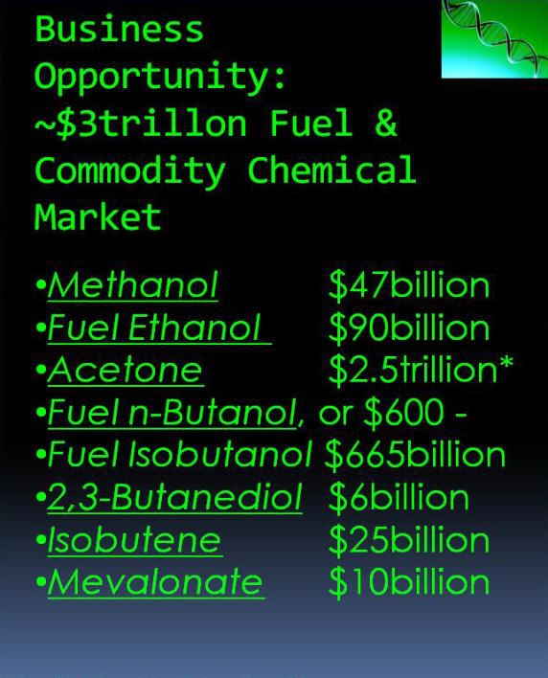

There are always additional business opportunities existing now and to be developed later on:

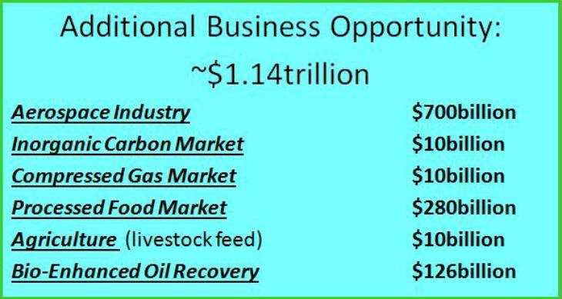

Our definite plan is to organize the commercial manufacture of fuel isobutanol using our carbon negative disrutive technology, published in 2019. The manufcaturing cost of said fuel isobutanol will be as follows:

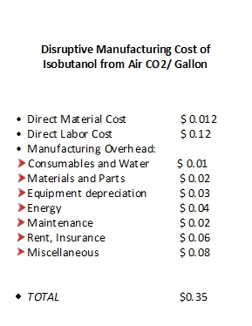

The Acetogens-biocatalysts look as shown on the picture:

This is the look of our proprietary biocatalyst obtained during the published in the peer-reviewed literature:



Dark colinies on this picture are the colonies of the resulting Acetogen strain-biocatalyst.

Said Acetogen-biocatalyst has the following carbon flow:



The look of our Acetogens-biocatyalysts cells is shown below.



The absence of the competition on the existing over $3.2 trillion market of fuels and commodity checmicals for Dr. M.V. Tyurin has been guaranteed after he has invented his own unique electroporation/electorfusion generator used for the purpose of genetic engineering of his unique proprietary Acetogen biocatalyst, principal scheme of which is shown below.



The absence of the competition on said over $3.2 trillion market of the fuels and the commodity checmicals is determined by the facts, that the existing commercially available (our generator is also commercially available, but its the manufacturing price does not allow to many professors to purchase it). As you can see from this circuit diagram, the core of this Dr. Tyurin’s invention (Russian Patent 2-005776) is the power tetrode, and the cell sample is connected in series to its anode circuit, powered by the special power capacitor delivering when required by the cell samples high frequency electronic oscillations, typical for each particular cell sample. Said high frequency electornic oscillations result from the real time electric response of the target cells to the applied electric pusle. Said high frequency electric oscillations generation is specific for each particular target cell type, and it cannot be imposed to the curcuit from the outside, it has to be developed only by the particular cell sample, and it is the electric responce of the target cell sample to the square electric pulse applied to the traget cell sample. Said generation of said electric oscillations is impossible in any sort of the available for other researchers community the electropration generators made by other corporations world-wide. Said generators are, available commercially (not to include our electroproation/electriffusion generators also available commercialy only from our businesses.

The typical oscilloscopic images obtained for the electrotransformation of Acetogens are shown below.



Under the electric treatment of Acetogen cells, all commercilally available on the market (not to include our also commercially available generator, made under the Russian Patent 2--005776) devices shown significant changes of the applied to the target Acetogen cells electric pulse form, determining the absence of the electrotransformation event for the Acetogens as shown in the image below.



Said experimental failures in the hands of other scientists, trying to work with the Acetogens are determined by the output problems in the existing for sales (not to include our electropration/electrofusion generators) generators for the cell electric treatment as shown below.



Therefore, we plan to add the additonal businesses to the existing structre of our businesses, mainly limited by the fuel Isobutanol manufacturing capability at our site. Said additional businesses will be further evaluating the required by our unique experemtnal base changes of the electronicx equipment we want to explore further in our site near Brownsville, TX.

This is the form of the output electric pusle in the newly developed generator for the electrotransformation/electrofusion of various cell types, including also animal and fingal (higher aorganisms), not only bacteriall and fungal cells.

